**Problem 1: Verify the joint pmf of the Bernoulli sample on page 9 of Slides02 and show**

**that it depends on the sample only through the sample mean.**

Slides02, page 7

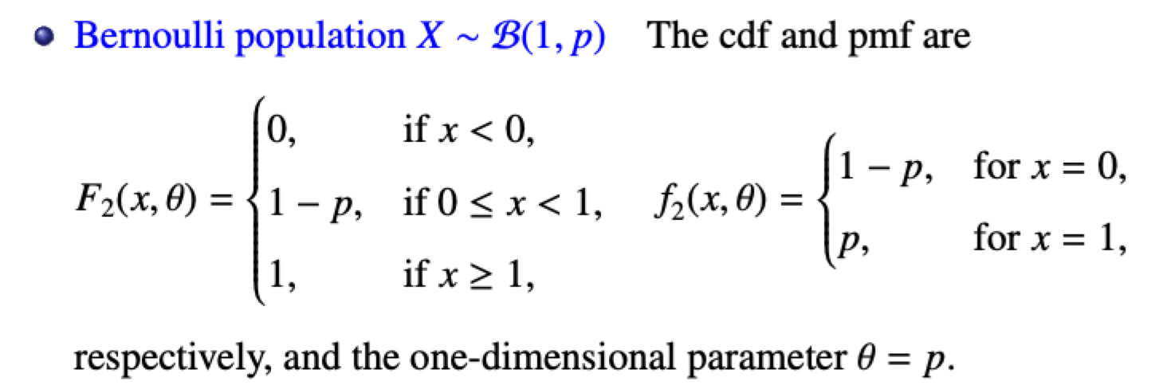

Slides02, page 9

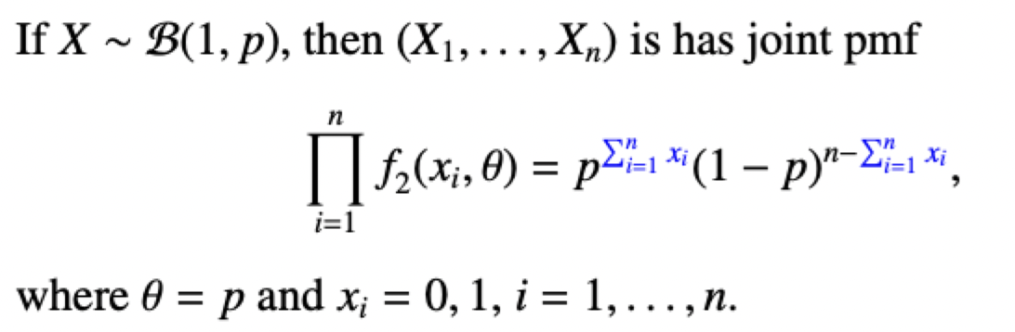

Step 1 & 2: Relating the sample mean to the summations, figuring out the summations for the number of times we have x = 0 and x = 1

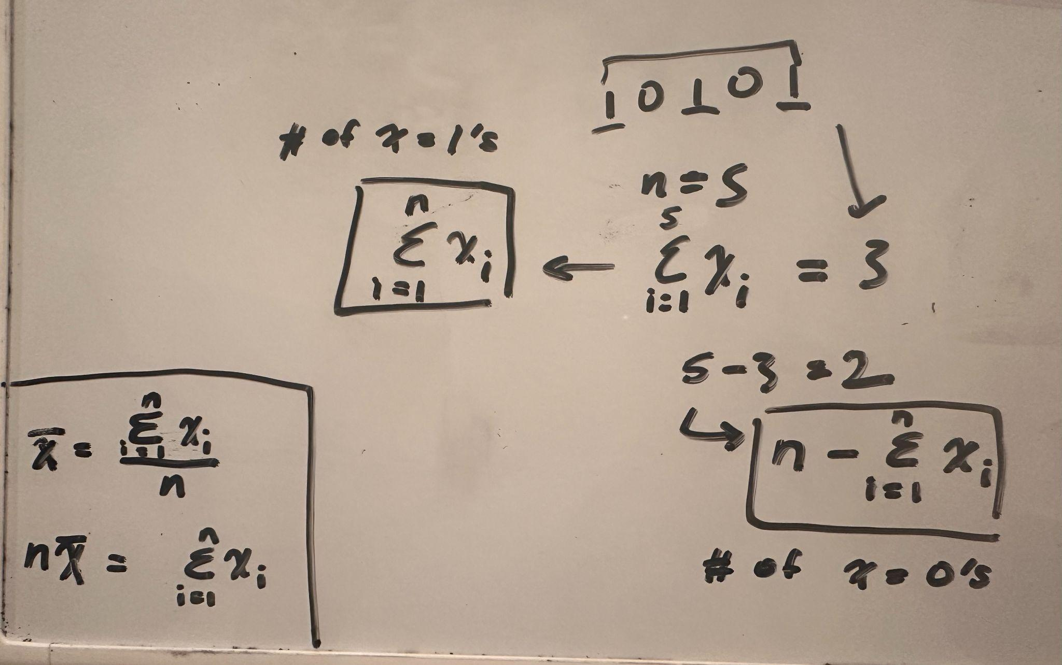

Step 3 & 4: Finding the product as it relates to the number of x = 0’s and x = 1’s, then substituting that in with n*sample mean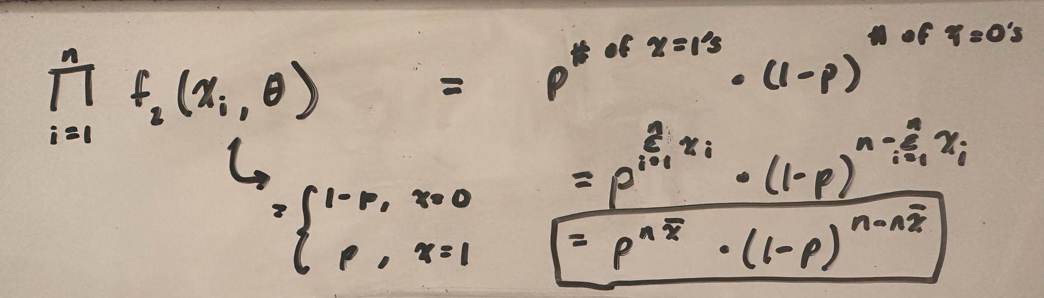

**Problem 2: Verify the joint pdf of the normal sample on page 9 of Slides02 and show**

**that it depends on the sample only through the first two sample moments.**

Slides02, page 7

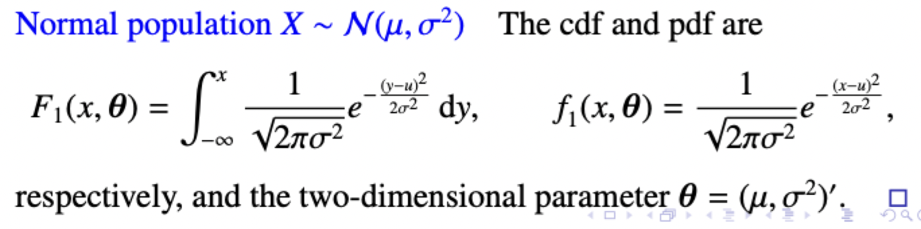

Slides02, page 9

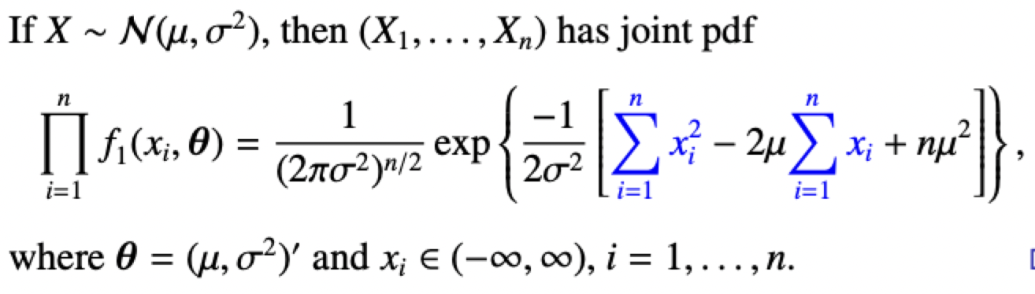

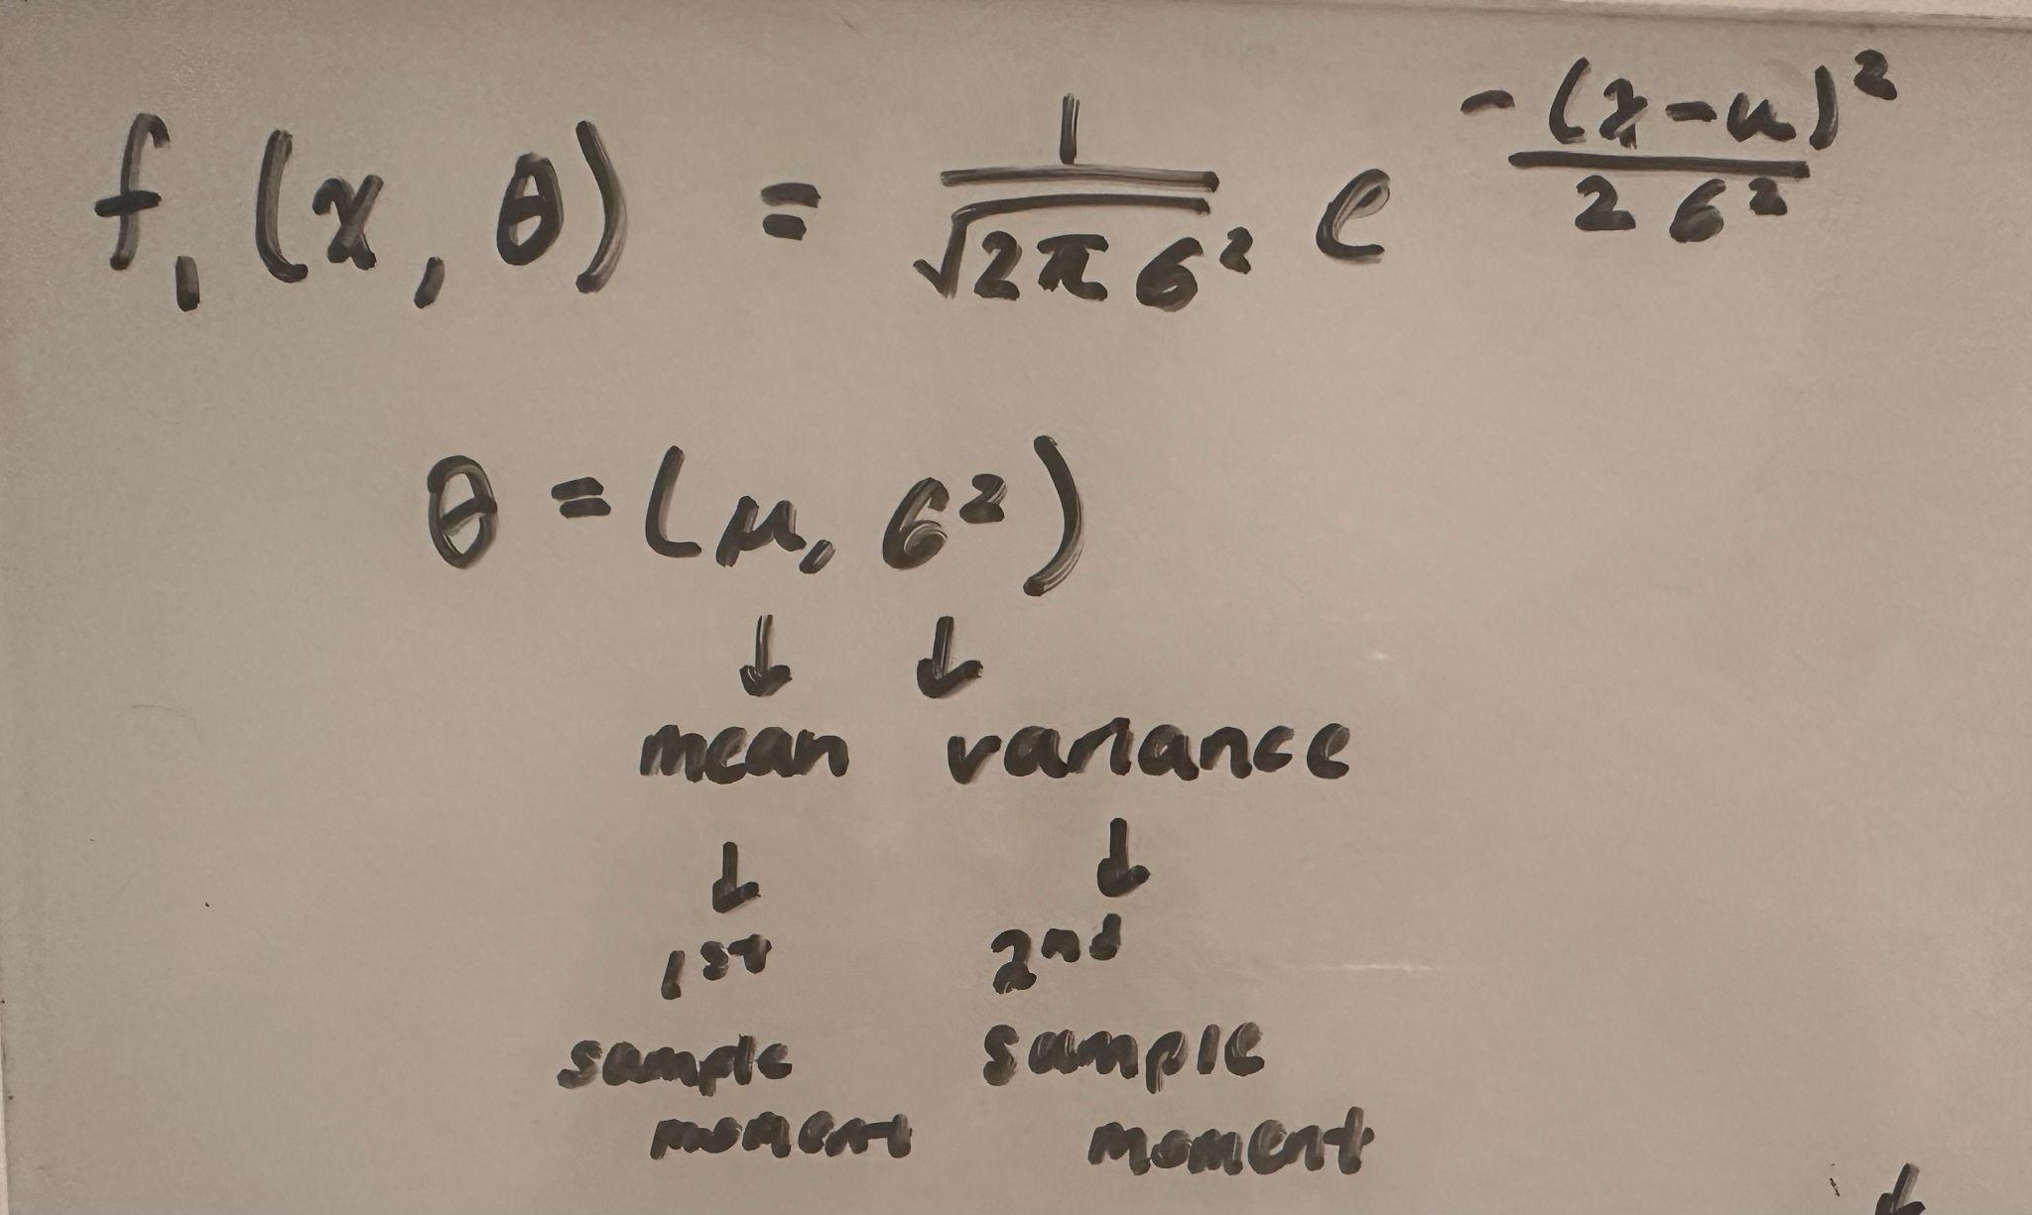

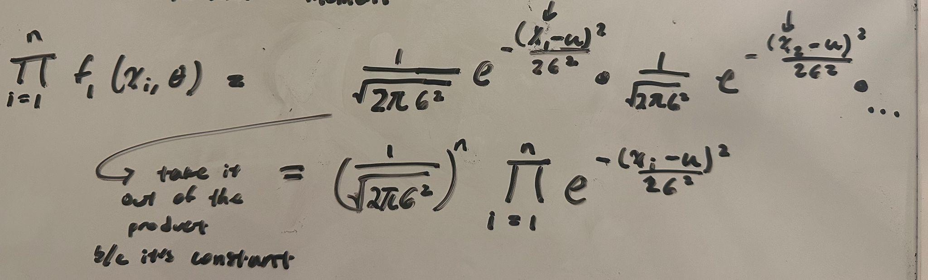

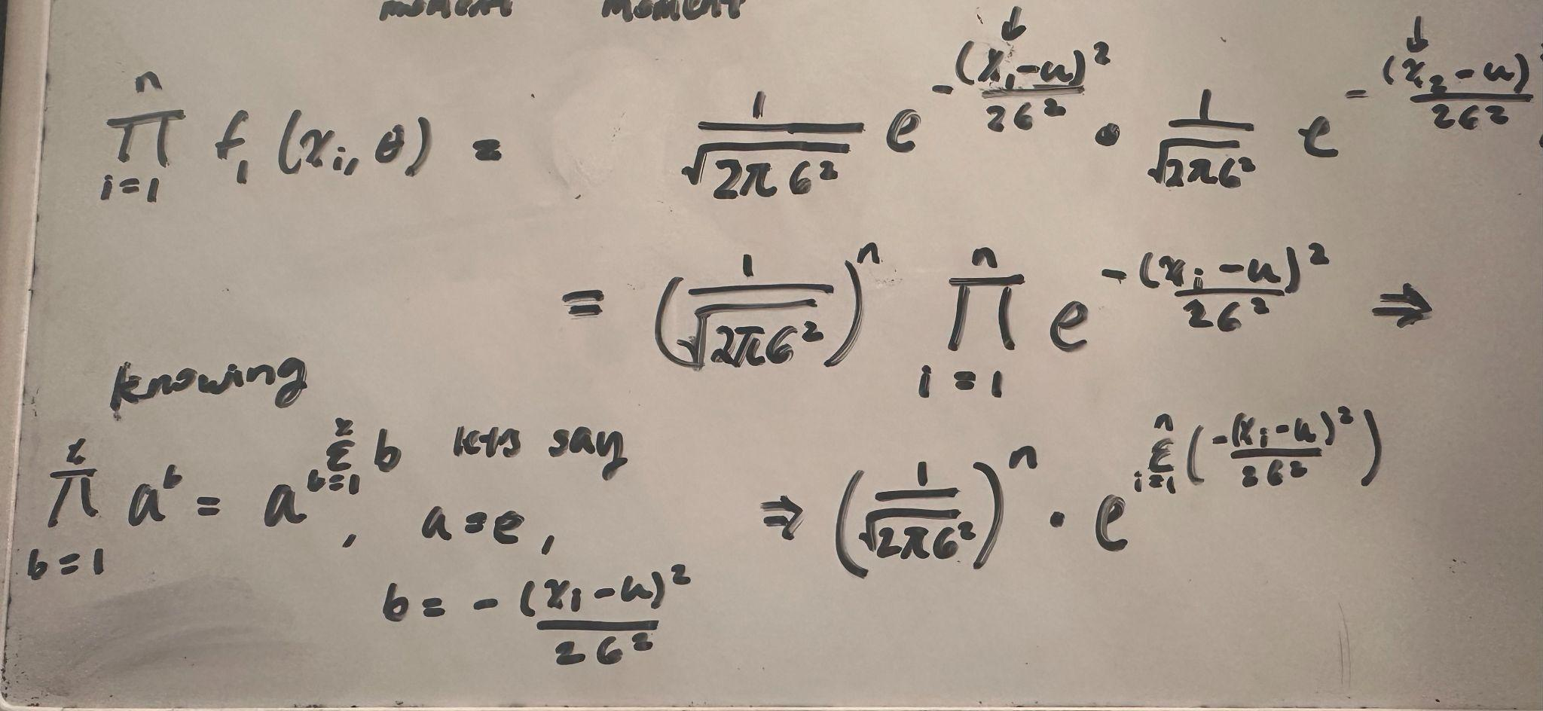

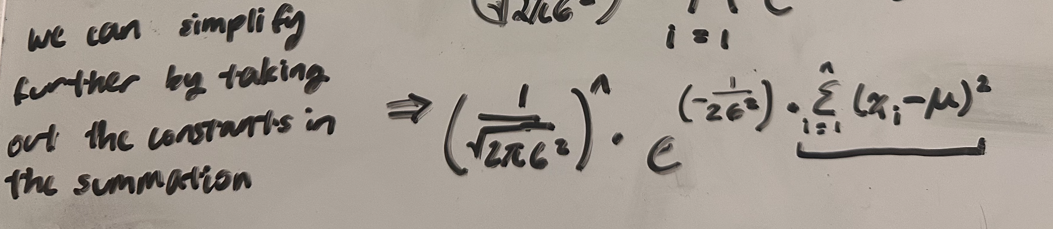

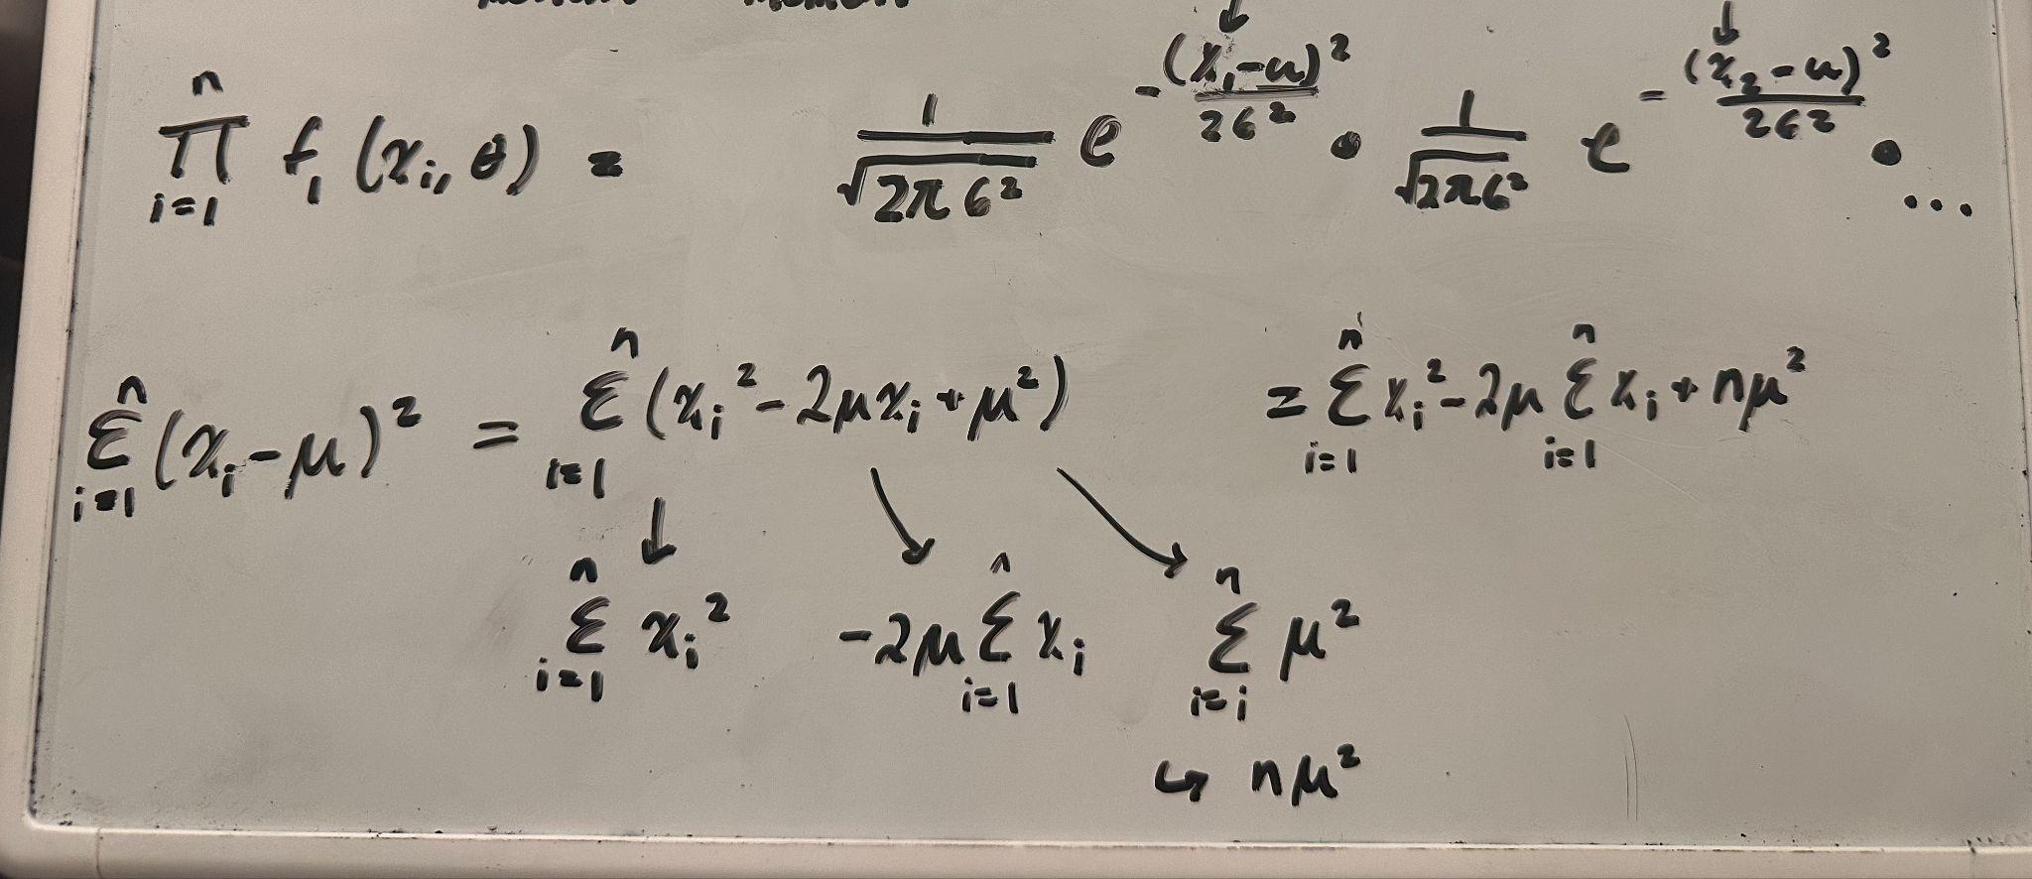

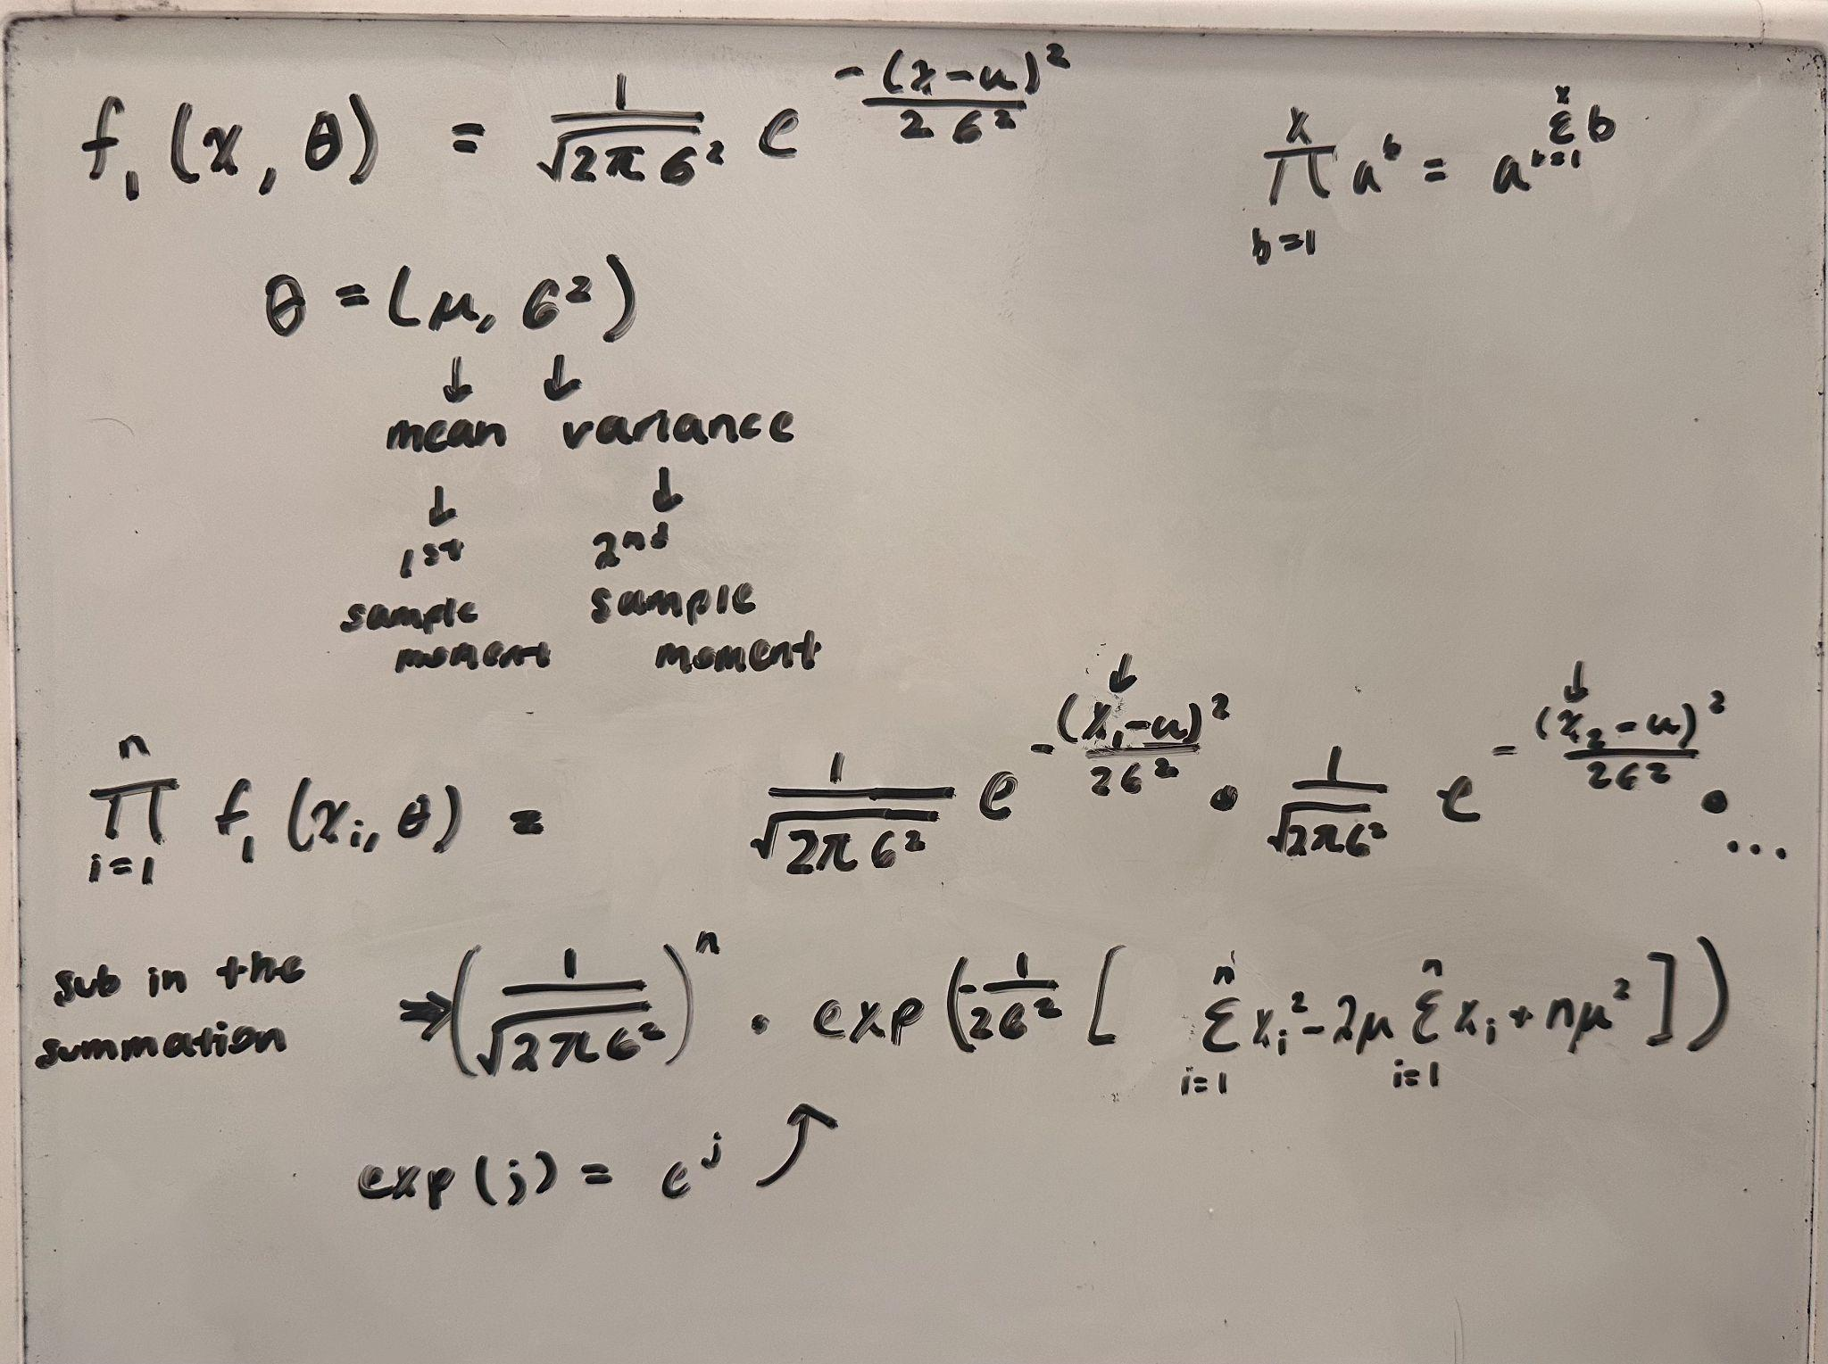

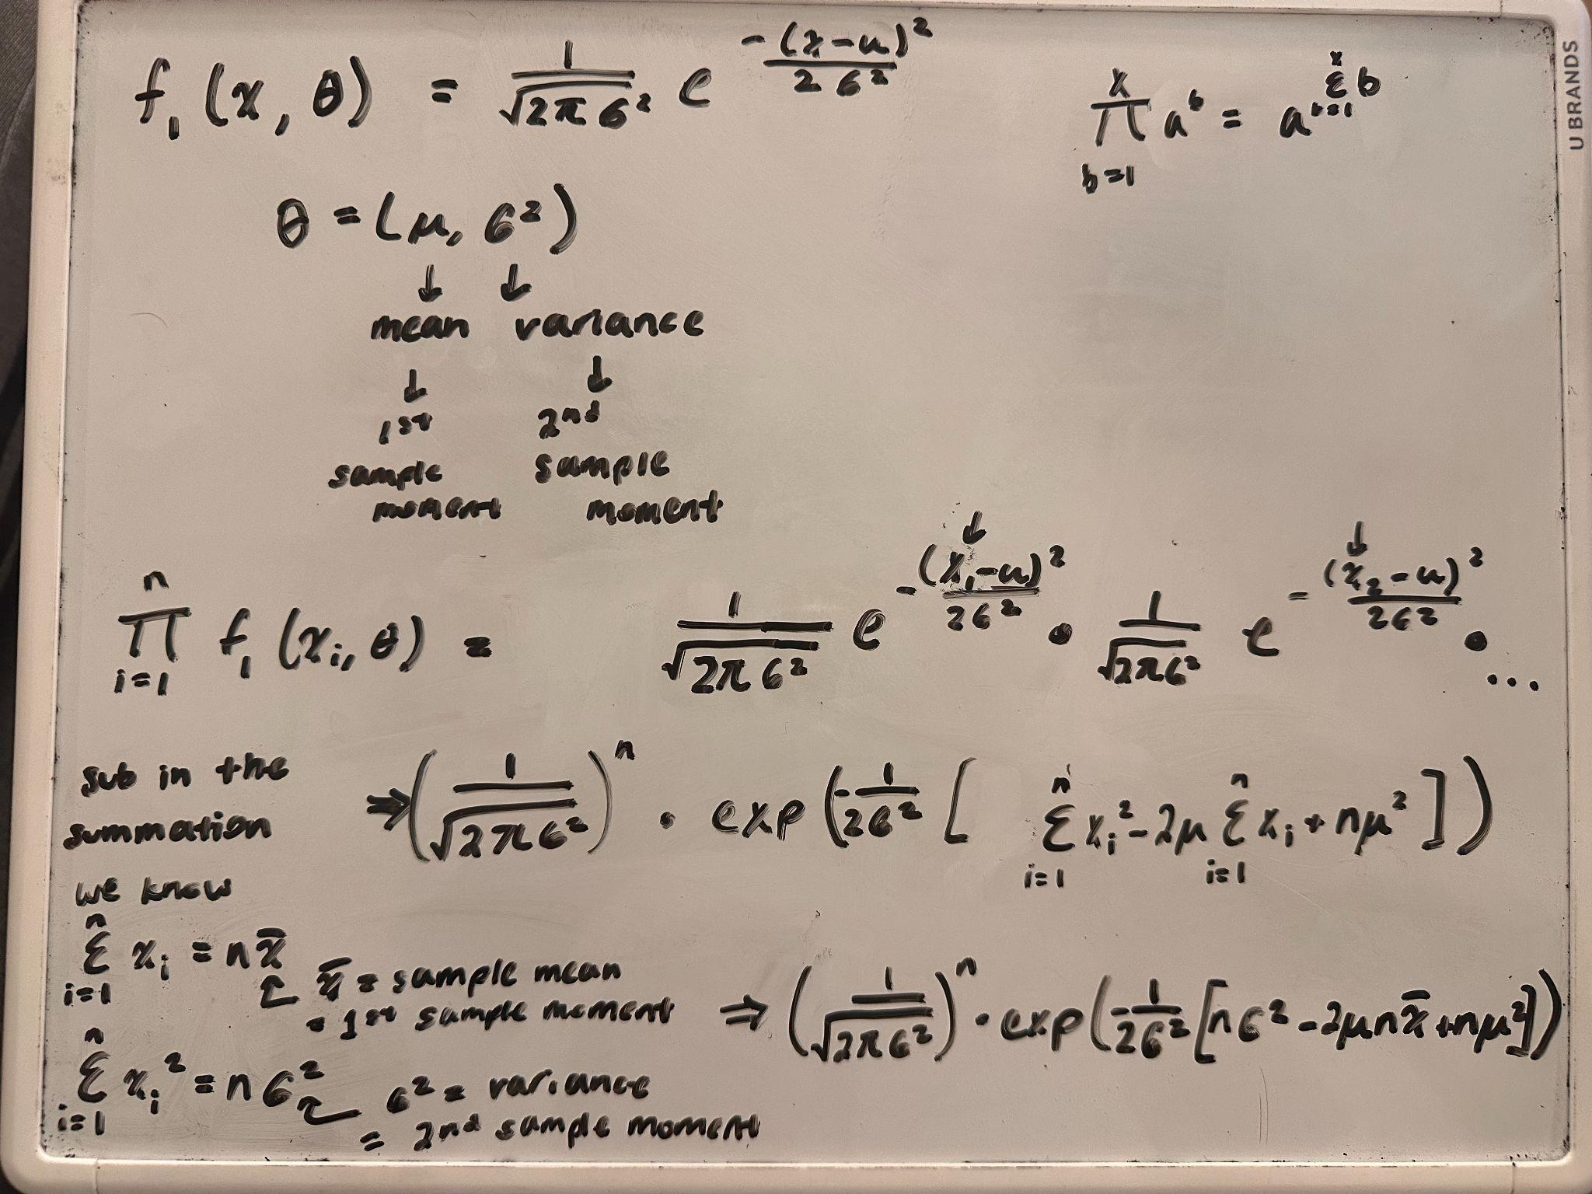

**Problem 3: Suppose X ∼ N (μ, σ2). Show that (X−μ)/σ ∼ N (0, 1), the standardization on**

**page 20 of Slides02.**

Slides02, page 19

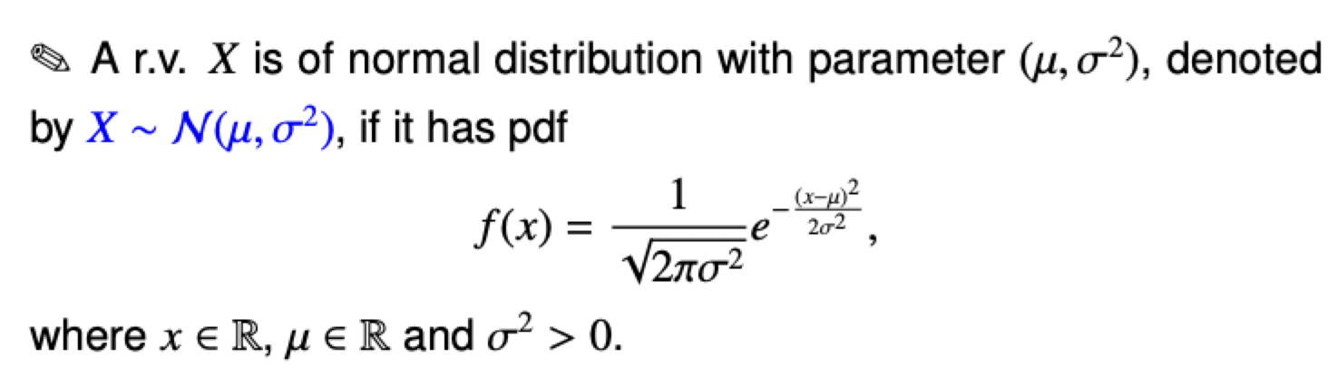

Slides02, page 20

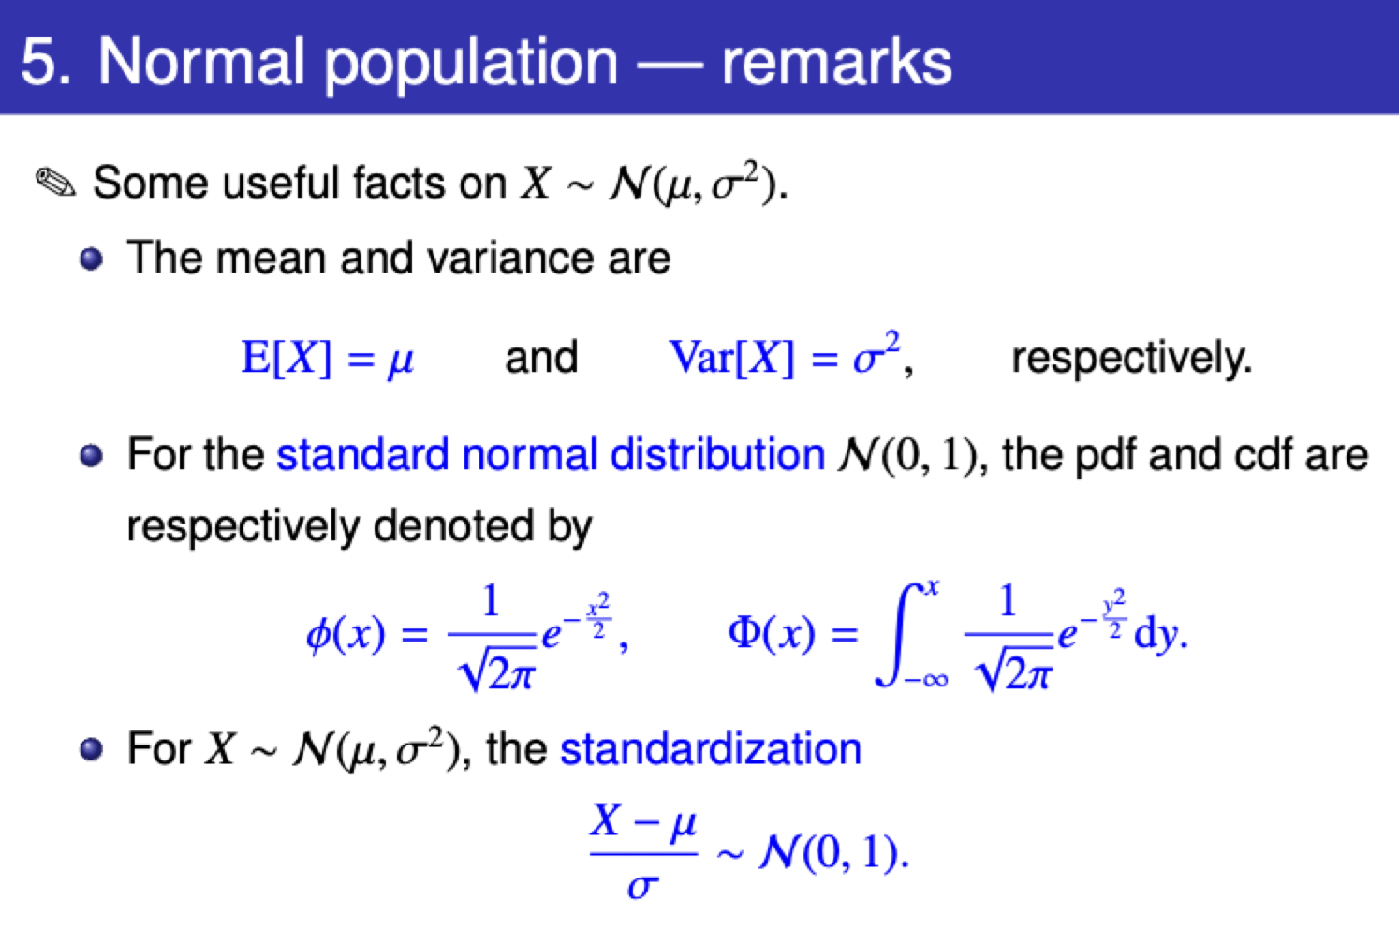

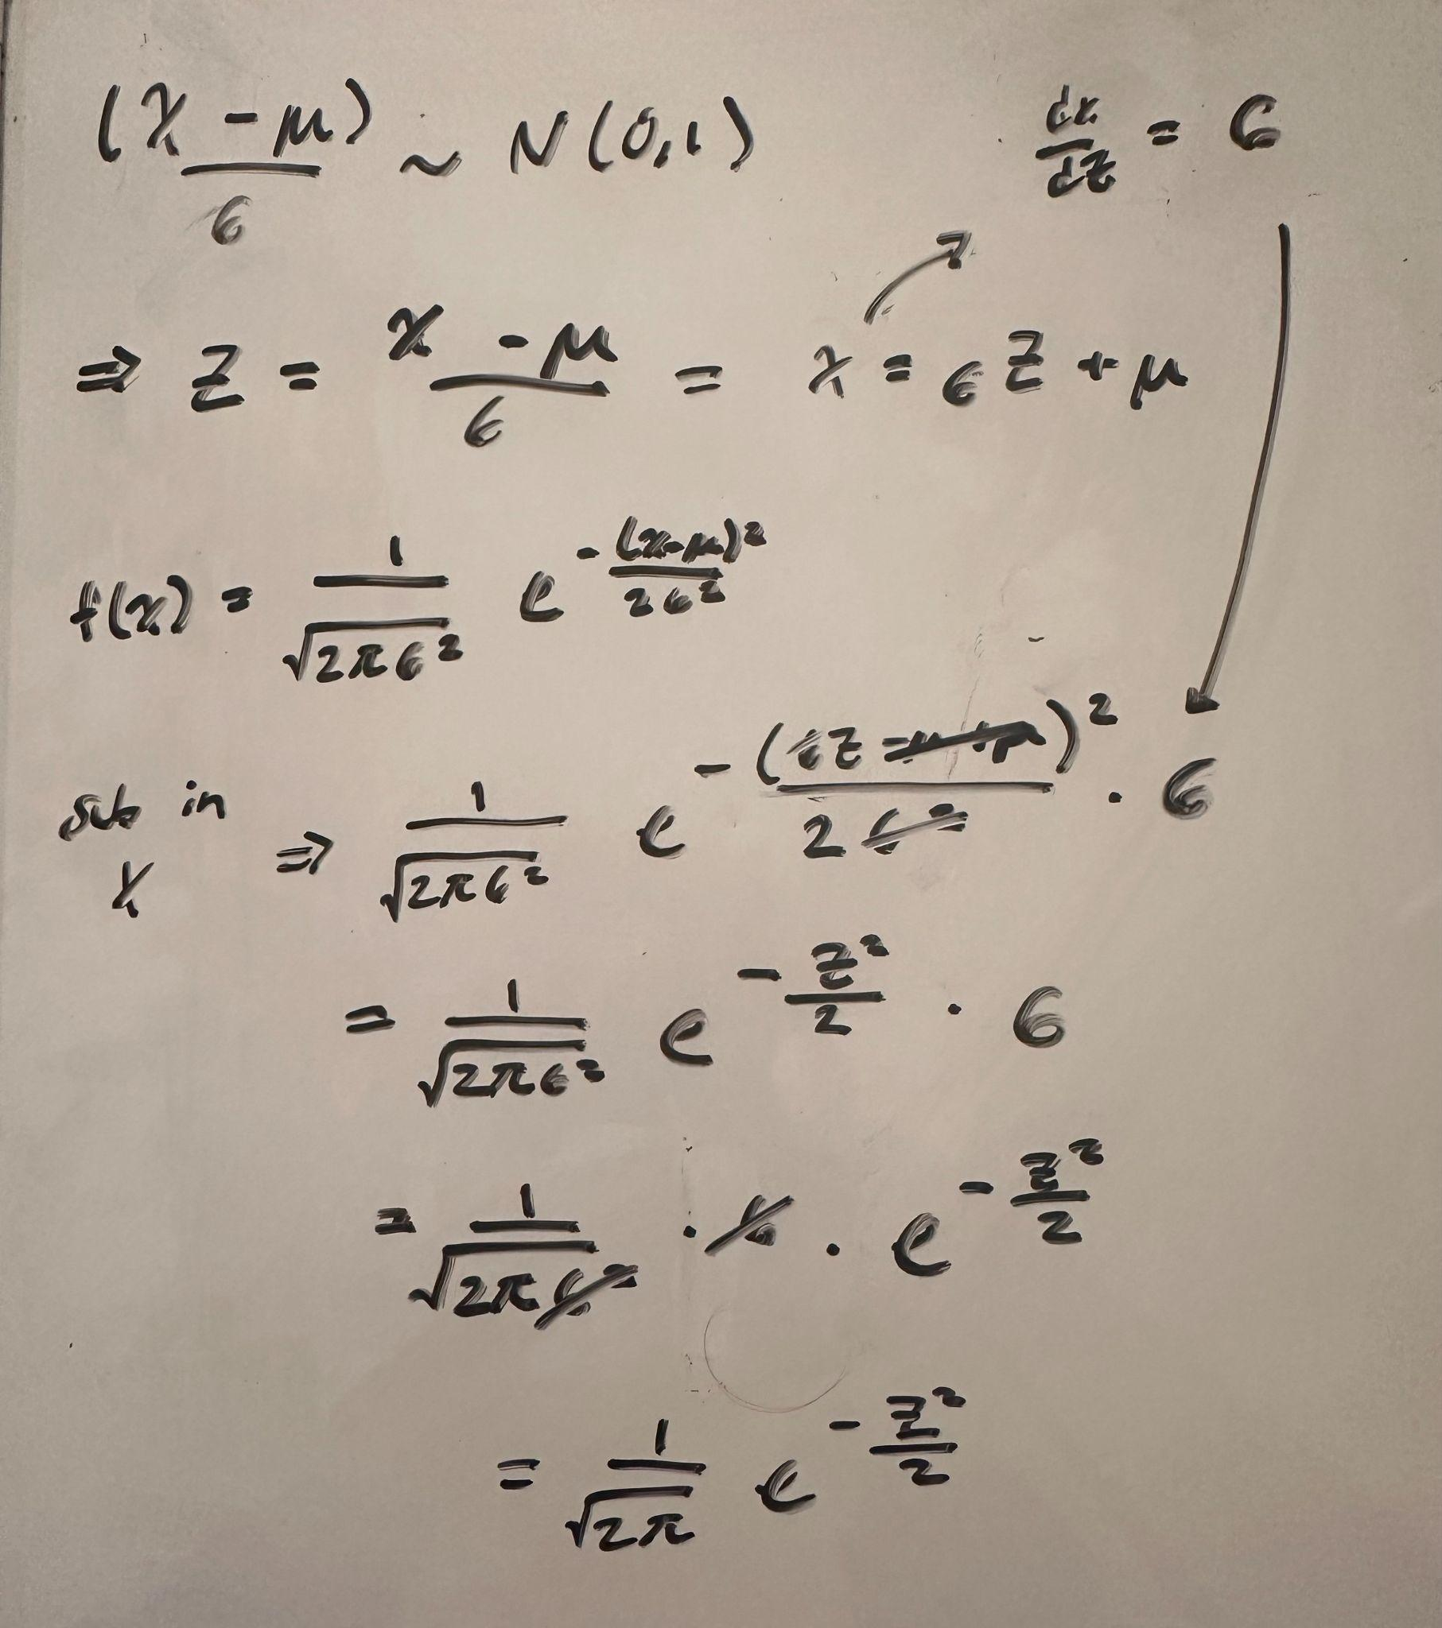

**Problem 4**

1. The original population is the entire block of goods.
2. $X=\{X_{1}, ... , X_{n}\}$ where $X_{i}=1 if defective, 0 if qualified, where i=1, ..., n$.
3. $X \sim B(1,\frac{d}{d+m})$, which means its cdf is: $F(x, \frac{d}{d+m})=0, if x<0,$

$= 1-\frac{d}{d+m}, if 0≤x≤1,$

$= 1, if x≥1$

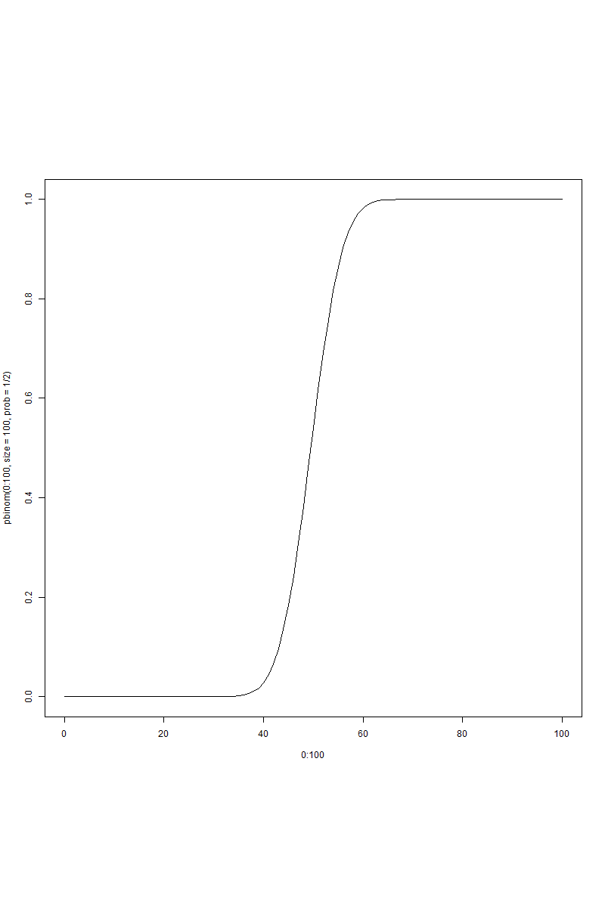

**Problem 5**

$X_{i} = 1 if defective, 0 if qualified, where i=1, ..., n.$

1. No. When chosen with replacement, the sample is no longer a SRS.
2. The probability does not change per good, so $p=\frac{d}{d+m}$.

$N_{1}\sim B(d+m,\frac{d}{d+m})$

$E[N_{1}]=np=(d+m)(\frac{d}{d+m})=d$ $Var[N_{1}]=np(1-p)=d(1-\frac{d}{d+m})=\frac{dm}{d+m}$

**Problem 6**

1. Yes. Assuming they were randomly selected and each good is mutually independent, drawing with replacement will yield a SRS.
2. On the second trial, $p=\frac{d}{d+m-1}$ or $\frac{d-1}{d+m-1}$, depending on if the first trial yielded a qualified or defective good, respectively.

$N_{2}\sim Hypergeometric(d+m, d, 1)$

$E[N_{2}]=(d+m)\frac{d}{d+m}=d$

$Var[N_{2}]= n\frac{K}{N}\frac{N-K}{N}\frac{N-n}{N-1}=\frac{d}{d+m}\frac{m}{d+m}=\frac{dm}{(d+m)^{2}}$

**Problem 7**

1. $N_{1}=\{X_{1}, ... , X_{n}\}$, where some Xs may be observations of the same goods. $N_{2}=\{X_{1}, ... , X_{n}\}$, where all of the Xs will be observations of different goods.
2. $E[N_{2}]=d=E[N_{1}]=d$. Both formulas are equal to $np$. It makes sense because the data doesn't change, no matter how we sample it.
3. $Var[N_{2}]=\frac{dm}{(d+m)^{2}}≠Var[N_{1}]=\frac{dm}{d+m}$. The way we sample the data has changed, so it makes sense that the variance changes.